 





STUDENT MANAGEMENT SYSTEM



















This is to certify that Chhavi Saxena of Class XII bearing Roll No. has completed his project on “Student Management System” in accordance with specifications prescribed by CBSE BOARD, New Delhi.

Teacher’s Signature Examiner’s Signature

|  |  |
| --- | --- |
| ***S.NO.*** | ***CONTENTS*** |
| ***1.*** | **Acknowledgement** |
| ***2.*** | **Preface** |
| ***3.*** | **Hardware & Software Requirements** |
| ***4.*** | **Database Design** |
| ***5.*** | **Program Coding** |
| ***6.*** | **Output Screens** |
| ***7.*** | **Bibliography** |

**Completion of any work or project depends upon the cooperation and coordination of team-mates and proper guidance.**

**Now, I am very pleased to present my project report successfully. I feel very fortunate to express my feeling about all the concerned teachers & all the friends who have contributed valuable suggestions for improvement.**

**I have taken this opportunity to express my deepest regard & gratefulness to honourable Computer Teacher, Poorva Dwivedi ma’am, whose valuable guidance, heartening encouragement & sympathetic attitude at every step have steered this topic to its successful completion.**



**1. The student management system interface in Python provides a user-friendly and intuitive platform for managing student data.**

**2. With SQL connectivity, the system can seamlessly retrieve and store student information in a secure and efficient manner.**

**3. Through Python and SQL integration, the student management system interface enables real-time updates and synchronization of student data across multiple platforms.**

**4. The Python-based interface allows for customizable reporting and analysis of student data, leveraging the power of SQL for efficient data retrieval and manipulation.**

**5. With SQL connectivity, the student management system interface can handle large volumes of student data with ease, ensuring smooth and reliable performance.**

**6. The Python-based interface offers a seamless user experience, with SQL connectivity providing a robust and secure foundation for managing student information.**

**7. The system's interface, powered by Python and SQL connectivity, ensures that student data is stored and managed in a secure and efficient manner, meeting the needs of educational institutions.**

* **Processor Required : Dual/Quad Core, 3.60 GHz**
* **RAM : 4 GB**
* **Operating System : Windows 11**
* **Front End Tool : Python IDLE 3.11.5**
* **Back End Tool : MySQL 8.1.0**

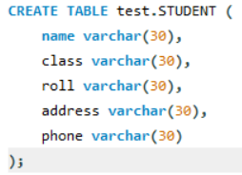



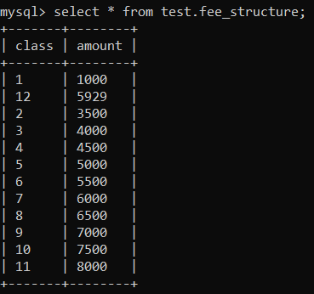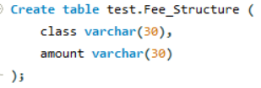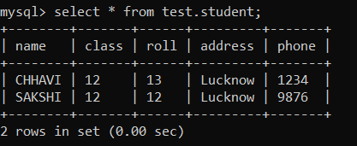



**import mysql.connector as a**

**# connect to database**

**con=a.connect(host='localhost',user='sample', database='test',passwd='user123')**

**def AddSt():**

**n=input("Student name: ")**

**r=input("Roll no:")**

**cl=input("Class:")**

**a=input("Address:")**

**ph=input("Phone: ")**

**sql="insert into test.student (name, roll, class, address, phone) values ('{n}','{r}','{cl}','{a}','{ph}')"**

**c=con.cursor()**

**c.execute(sql)**

**con.commit()**

**print("Data entered successfully")**

**print("")**

**main()**

**def RemoveSt():**

**name=input("Name of student: ")**

**r=input("Roll no of student: ")**

**cl=input("class of student: ")**

**sql="Delete from student where name = '{name}' and class = '{cl}' and roll = '{r}'"**

**c=con.cursor()**

**c.execute(sql)**

**con.commit()**

**print ("Data deleted successfully")**

**print("")**

**main()**

**def DisplaySt():**

**cl=input("Class:")**

**sql="select * from test.student where class='{cl}'"**

**c=con.cursor()**

**c.execute(sql)**

**d=c.fetchall()**

**print("--------------------------------------------------")**

**print("Name, Class, Roll No, Address, Phone")**

**for i in d:**

**print(f"{i[0]}, {i[1]}, {i[2]}, {i[3]}, {i[4]}")**

**print("--------------------------------------------------")**

**main()**

**def UpdateFees():**

**cl=input("Enter Class: ")**

**fees=input("Enter the new Fees: ")**

**sql="update test.FEE_STRUCTURE set amount = '{fees}' where class = '{cl}'"**

**c=con.cursor()**

**c.execute(sql)**

**con.commit()**

**print("Data updated successfully")**

**print("")**

**main()**

**def DisplayFees():**

**sql="select * from test.FEE_STRUCTURE;"**

**c=con.cursor()**

**c.execute(sql)**

**d=c.fetchall()**

**print("------------------------------------------")**

**print("Class Fees")**

**for i in d:**

**print(f" {i[0]} : {i[1]} ")**

**print("------------------------------------------")**

**main()**

**def main():**

**ch='y'**

**while ch in ['y', 'Y']:**

**print("########################################################")**

**print("# LUCKNOW PUBLIC SCHOOL DATABASE MANAGEMENT SYSTEM #")**

**print("# Table Number | Table Name #")**

**print("# 1 | Student #")**

**print("# 2 | Fee_Structure #")**

**print("# Press 3 to quite application #")**

**print("########################################################\n")**

**table=int(input ("Enter table Number to operate: "))**

**print("")**

**# Student Table condition**

**if table==1:**

**op='y'**

**while op in ['y', 'Y']:**

**print(".------------------------------------------------------.")**

**print("| Task Number | Operations |")**

**print("| 1 | Add student |")**

**print("| 2 | Remove student |")**

**print("| 3 | Display St detail |")**

**print(".------------------------------------------------------.")**

**task=int(input("Enter task no to operate:"))**

**if task==1:**

**AddSt()**

**elif task==2:**

**RemoveSt()**

**elif task==3:**

**DisplaySt()**

**else:**

**print("Please enter a valid choice!!")**

**op=input("Continue in this table(y/n):")**

**# Fee Structure condition**

**elif table==2:**

**op='y'**

**while op in ['y', 'Y']:**

**print(".------------------------------------------------------.")**

**print("| Task Number | Operations |")**

**print("| 1 | Update Fees |")**

**print("| 2 | Display Fees |")**

**print(".------------------------------------------------------.")**

**task=int(input("Enter task no to operate:"))**

**if task==1:**

**UpdateFees()**

**elif task==2:**

**DisplayFees()**

**else:**

**print ("Enter Valid Choice!!")**

**op=input("Continue in this table (y/n) :")**

**# Quit application**

**elif table==3:**

**break**

**# Invalid choice provided by the user**

**else:**

**print("ENTER VALID CHOICE!!!")**

**ch=input("Do you want to continue (y/n): ")**

**if __name__ == '__main__':**

**print("CLASS 12th Project on Student Management System made by-")**

**print("CHHAVI SAXENA")**

**main()**



**Main menu operations**

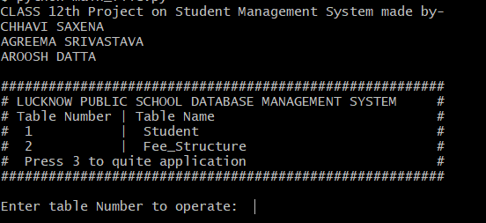

**To add a student to school database**

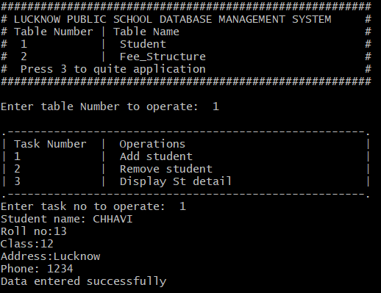

**To Display students in school database**

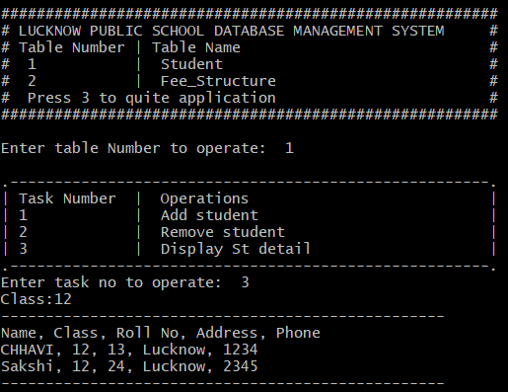

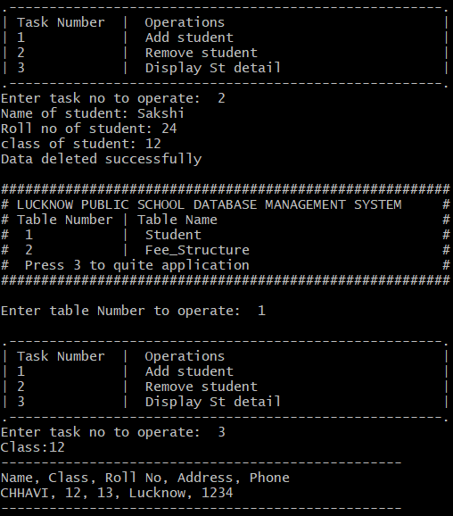**To delete students from school database**

**To update& display fee structure**

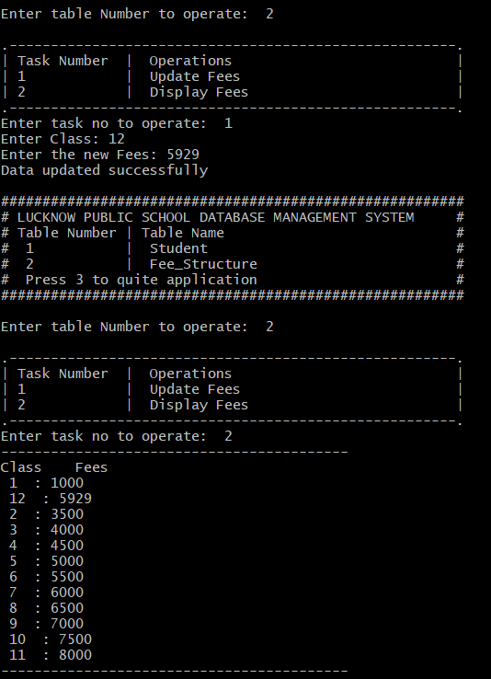



**TUTORIAL**S

1. CLASS NOTES given by Subject Teacher
2. A Sample Project made by Subject Teacher

**BOOKS**

* Computer Science With Python –

A Text Book for Class XII

By Sumita Arora